To update the email for the password reset:

1. Login to ELIS for Educators

2. Select "Edit Profile"

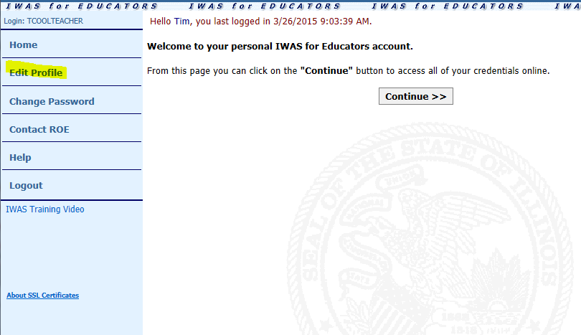

3. Update email address
4. Select Yes from the "Broadcast Email" dropdown
5. Select HTML from the "Email Type" dropdown
6. Click "Submit"

